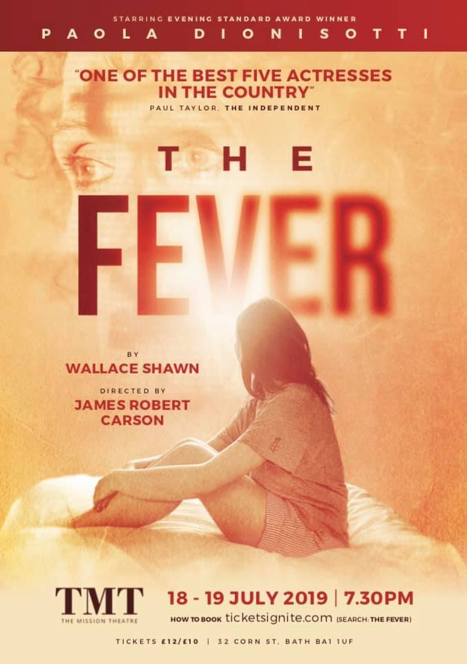

About The Fever

“...sympathy for the poor does not change the life of the poor. And artists who create works of art that inspire sympathy and good values don’t change the life of the poor.”

It’s 1989. A western woman wakes up in a hotel room, shaking and shivering, in a country that is not her own. Her illness is onset by a sudden awareness that the poverty of others has afforded her a rich and comfortable life. Now, she challenges you with the questions that could poison your life.

Paola Dionisotti’s performance of The Fever is passionate, probing and powerful. In 2019 Brexit Britain, Paola offers a fearsomely honest exploration of our moral obligations in an affluent society, and opens up the floor for you to join her in discussing them.

Length of show
90 minutes

Age range
14+

Trigger warning
Contains descriptive scenes of a violent nature

Booking Link
https://www.ticketsignite.com/event/1196/the-fever

Audience testimonials

Juliet Stevenson - actress “Wallace Shawn’s brilliant exploration of the personal and the political is startlingly challenging. Its full of the unexpected - and by turns revelatory, witty, ironic and piercingly insightful. Paola Dionisotti’s performance of it is astonishing - it’s a hypnotic experience, watching her fill out the play’s arguments with intellectual and creative brilliance, but with a mesmerising sensuality too. As a vividly inhabited exploration of the moral quandaries of being alive in 2019, it’s a must see.”

Laurian Adams - former education manager “Not a piece with a formal structure The Fever nevertheless held the attention of the audience telling a story for our time... A marvellous introductory piece for people new to theatre going.”

Sian Evans - playwright, creative writing tutor at University of East Anglia “I lost my copy [of The Fever] when I lent it to some friends in the wake of 9/11. Such a shocking and destructive event left them baffled. Shawn’s play seemed to me to offer some insight into why it had taken place... I was thrilled to hear that Paola Dionisotti was going to take on the play. Such an extraordinary monologue requires an extraordinary actress... Simply and economically directed by James Robert Carson this production manages to capture the strange and delicate balance of intimate and epic...This is a play (and a performance) that changes lives.”

Vivien Barr - published author, manager in adult and further education “ As someone who has spent her working life with young people I want to stress how important the theme is - the predicament of those in the developed world with their preoccupation with good service and value for money - while being only intermittently and impotently aware of the extreme deprivation around them. I have not seen this being addressed elsewhere and I think young people should have the opportunity to see The Fever and reflect on this issue.”

Patrick Sandford - former artistic director, Nuffield Theatre, Southampton “This is quite simply a terrific evening of theatre of the highest quality. The play is still vibrantly important in its portrayal of the major ethical questions of 21st century western society. Paola Dionisotti's performance is masterly in its emotional punch, and in its accessibility. She succeeds in being 'ordinary', so just like any one of us in the audience, in a quite extraordinary way. Powerful, moving, funny, terrifying. The play should be seen by audiences everywhere, by anyone who cares about human beings.”

Scott Brown - head of student advice services at Central School of Speech & Drama “The Fever was one of the most invigorating evenings of theatre I have had in quite some time. It has been created with such care, passion and a fiery intellectual rigour that makes you want to come back and see it again. It’s a piece for our troubled times: thank you for sharing it!”

H. O. Nazareth - retired poet, screenwriter & documentary producer/director “Now, at a time when Oxfam is publicising the fact that the 26 richest people in the world have as much wealth as the 3.5 billion poorest (half the earth's population), it is clear that there's a lot very wrong with how we humans are conducting ourselves. The Fever offers a graphic focus on this, and it has remained in my mind all these years. Paola's compelling performance of this very important work about the impossible dilemma of the humanist condition is bound to make an impact on any and every one who sees it.”

Evanthe Blandy - psychoanalytic psychotherapist “The play’s message is particularly pertinent for younger people at a time when they are protesting about the government not taking global issues seriously enough which affects us all. A theatrical tour de force by Paola, who has made the part her own. She plays with conviction, passion, and intensity, and creates a strong connection with the audience...This theatrical experience has woken me up from any complacency about my place in the globalised economy. It is not a comfortable place!”

Stephanie Fayerman - actress “The political and cultural environment in which Wally first wrote the play has changed almost beyond recognition. But in the current febrile atmosphere of 'alternative facts', internet trolling and 'fake news', it has never been more critically important that The Fever's writhing, whimpering struggle towards a moral honesty rings out loud and clear to all generations, regardless of class, gender or ethnicity.”

Hugh Brody - anthropologist, writer and filmmaker “The play has found the actor it needs; and the actor brings her wonderful and compelling skills to the play. Everyone interested in theatre and thought, acting as well as modern history, should be sure to get to see it.”

Ruth Seglow - child and adolescent psychotherapist "It was the vivid experience of being inside a woman's mind as she gradually wakes up to the harsh realities of a world that she had thought was hers to take her pleasure in as a 'tourist' that most stayed with me...This is very much a play for today, where many of us are waking up to a new, harsher reality from the one we have grown up with. This is true for those of us who were, like me, children of the 60's but I think too that it has powerful relevance for the children of the 'noughties' who are currently exposed to the cruel hypocrisies of a world that is not as it seems to be. Paola's performance is...unmissable and I urge people to see it. "

Margaret Shirley “The Fever struck me like music, with Paola serving as conductor, one part mellow, another part brooding, another swift and skillfully executed. Although exploring dark content and the myriad intricacies of an unravelling mind, it wasn't turgid nor heavy, but variously energetic and multi-layered. My whole family enjoyed the performance.”

Timothy Lawrence-Cave - studio administrator, University of East Anglia “At times impassioned, at other heavy with a weight of world-weariness, Paola Dionisotti holds a taunt energy between herself and the audience, drawing them all forward.”

NB These words are that of the individuals and do not represent the views of the organisations they may work for.

